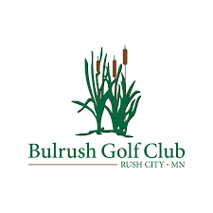
2022 All-inclusive Membership
- Includes golf / cart / range
- 20% discount on simulator time
- 10% discount on clothing
- 5% discount on food
Individual $1300
Couple $1900
Golf Membership
**Individual (Walking only) $725
**Junior (under 17) $125
Name:________________________________________________________________________
Address:_______________________________________________________________________
City/State/Zip:__________________________________________________________________
Phone:________________________________________________________________________
Email Address:__________________________________________________________________
** Memberships are not good during Charitable events.
*Sales tax not included
Early bird Special: Purchase your membership by Feb. 1st 2022, receive a Free Members only logo’d pullover. Size: ____________
Thank you for supporting and being a part of Bulrush Golf Club!

